# Template comes from manager with updated quarter end data

Exceptions to manager submission of data

Boundless

FRM – complete our report but no holdings detail

Westwood – line item only; get performance and AUM from manager

NBW Capital – line item – get only performance and AUM from manager

NAMICO

Zazove – complete our report but no holdings detail

Palo Verde

Proforma and Orbis – receive only AUM and performance for Performa for both

TO Date and due to a variety of reasons, we have not run a report for FNP Foundation, MIG, and NAMIC Plan

We track, on the spreadsheet entitled “Clients & Managers” which may be found on the team site, the receipt of the data from the manager. The spreadsheet is found by starting on the home page and selecting:

Client Reporting

CapVisor Client Reporting

Clients & Managers

Note the date the data was received in the manager cell for the client.

# Creating Files

Each client will have an Excel file called on the team site “<client name> Performance”. This file is stored in individual client folder on the team site under client reporting, Tabs in red are critical. The last two tabs are optional depending on whether or not we track the portfolio from that manager with a line item only. Download a copy of the performance file from the team site to update the data with the latest quarterly management report for that client.

## When the file is first created,

1. Choose appropriate short and long name in the “Client” tab. Short name is used to name the PowerPoint file; Long name is used in the title page of the presentation. Only one client in the client tab.
2. Enter manager information in “Manager” tab. It is critical to delete (not just erase) all rows and columns not used.

Manager names in the manager tab must match all over the spreadsheet, same with benchmarks ( MANAGER, FI, EQUITY, AUM and PERFORMANCE tabs) must match exactly ( even spaces must match)I made them all uniform and they should reflect the manager and/or strategy rather than the client.

1. Enter AUM information in “AUM” tab. It is critical to delete (not just erase) all rows and columns not used.
2. Enter Performance information in “Performance” tab. It is critical to delete (not just erase) all rows and columns not used. Benchmarks can not have special characters in them. Performance tab must be in percentage form.
3. Enter Risk Free Rate from FRED. See section below on getting this data. This data is same for all clients, but the quarters in risk free data must be the same as in Performance & AUM tabs
4. In “Chart Selection” tab, set options as appropriate. If the client’s managers don’t provide holding information, then set “Generate Fixed Income Analysis” and/or “Generate Equity Analysis” to “No”.
5. If holding data is available, delete all existing rows and enter information into the “Fixed Income” and “Equity” tabs. Make sure the data format from manager matches the format of the template.

## In subsequent quarters, when data is updated

1. Data in “Client” tab should not change
2. “Manager” tab should only change if new manager is added. The new manager information is added to the bottom of the table. Do NOT delete a row if a manager is terminated. This information is necessary for historical analysis
3. Add data on AUM to the bottom of table in “AUM”. If a manager is terminated, keep the column, but leave it blank.
4. Add new performance data to bottom of table in “Performance” tab. If a manager is terminated, keep the column, but leave it blank.
5. Append risk free rate from FRED. See section below on getting this data. This data is same for all clients.
6. Data in “Chart Selection” can be changed but will most probably be static.
7. If the client has either Fixed Income or Equity Holding data, make sure all the all prior data is removed from spreadsheet. For example, if in one quarter, the clients has 30 bonds, but in the next quarter, the client has 25 bonds, it is necessary that the last five rows are deleted.
8. The updated file can overwrite the existing file or saved in a different folder within the client folder if it is necessary to have archival records.

# Running Application

You will have a specific folder used by R to perform these calcuations. This <r folder> is separate from client folders.

1. Launch R Studio
2. When R Studio was set up, you will have created a project. This project name should show up on top right (A). The <r folder> should also show up in the lower left (B).

When you are ready to create the analysis,

1. Copy the “<client name> Performace” file to the <r folder> and rename it “Performance”. There will be only Excel file called “Performance” in the <r folder>
2. Once this is done, press “Source” (C) to create analysis.
3. If “stop” sign remains in lower left quadrant then R is not finished running.
4. Look for PP in R folder with clients name and ensure it is complete determined by a table of contents at the end of the presentation.
5. Send to Carl for review, then to Travis for editing. Travis will return a client version in PDF form and PP. He will also return the analyst version.
6. Creat a folder within the client folder on the team site for the particular quarter and upload all files previously mentioned to the current quarterly folder within each client’s file.
7. Repeat for all clients

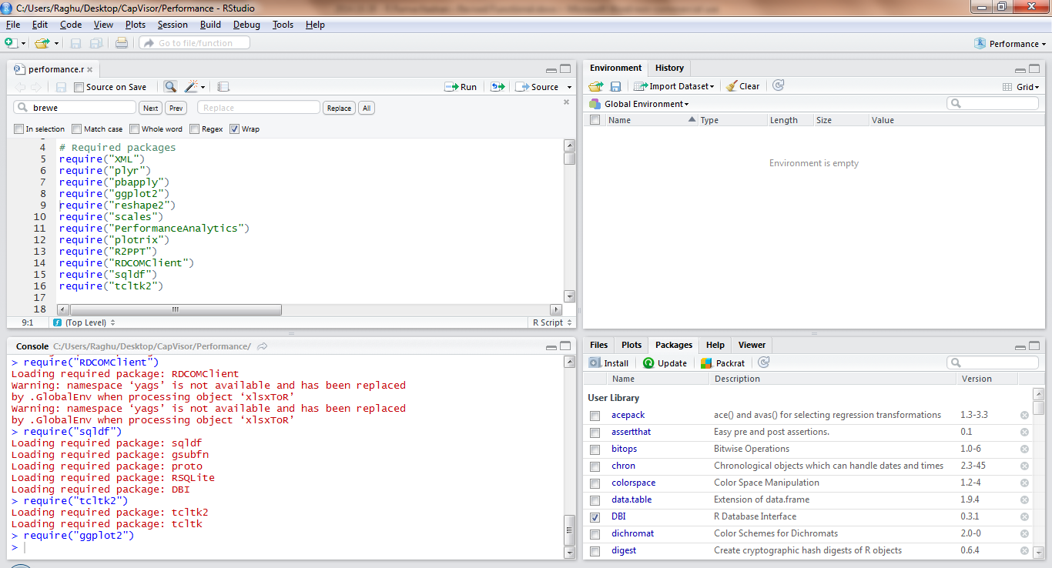

C

A

B

# S&P 500 Sector Allocation

The spx-sector.xlsx file has to be updated once a quarter with the latest sector allocation for S&P 500. This data is available from S&P – [Link](http://us.spindices.com/indices/equity/sp-500).

Select “Sector Breakdown” and copy numbers into spreadsheet

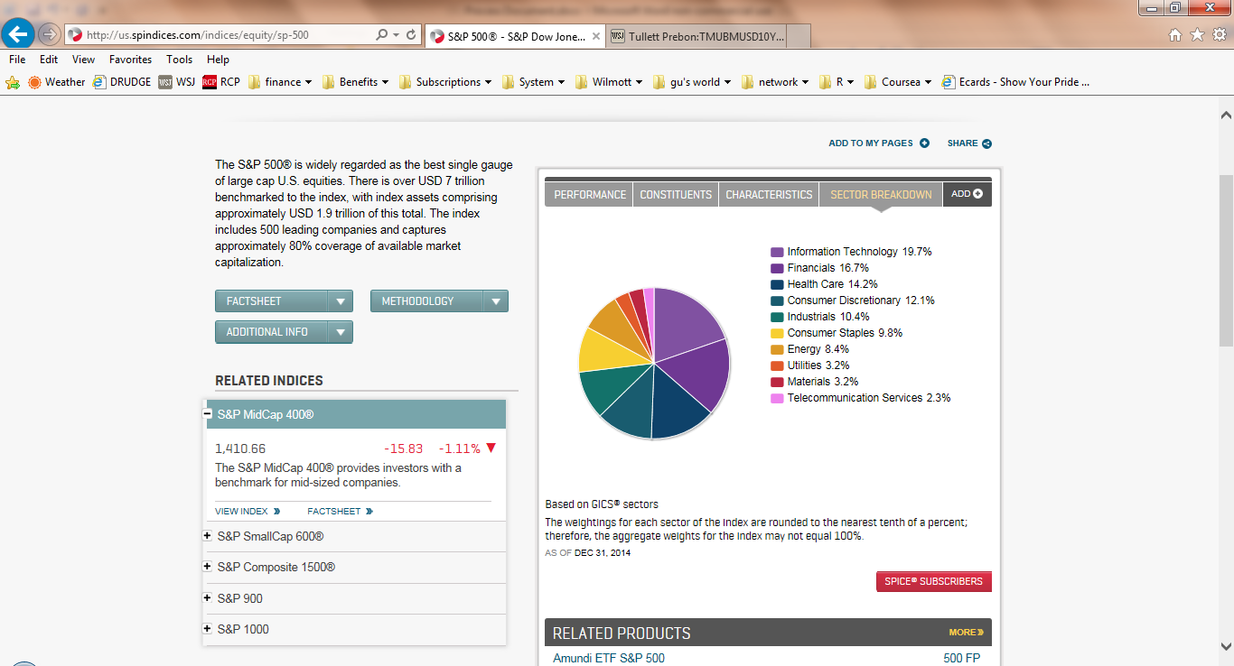

# Getting Risk Free Data

NOTE: In Performance, the date is the last day of the quarter; in Federal Reserve Data, the date is the 1st day of the quarter. For example, 4Q14 is 12/30/2014 in Performance but 2014-10-01 in Federal Reserve Data

Google 3 month Treasury Constant Maturity Rate and hover over the graph to the end of quarter date to get correct figure.

**Some trouble shooting points when completing template**:

1.Adjust all sector terms:

Equity

CONS. DISC.

CONS. STAPLES

ENERGY

HEALTH CARE

INDUSTRIALS

FINANCIALS

MLP

ETF/Mutual Fund

INTL ETF

IT

MAT.

TELCO

UTILITIES

REAL ESTATE

Fixed Income

CORP – TAXABLE MUNI

MUNI – general obligation (GO) or revenue bond or pre refunded, TAX EXEMPT

ABS – asset backed, other mortgage, pass thru

SOV. GOV.

PREF EQ – Preferred stock

INTL – Yankee (International), supranatural

TSY – US Government Bond, T-bill

MISC – mutual funds, international bond funds

ETF

CD

COMM MBS (issued by private institutions)

AGCY - Agency Bond

-GNMA CMO

-US MBS (issued by gov)

-FGLMC

-FNMA

-GNMA

-FHLMC CMO

-AGCY CMO

CASH – cash

- MM Fund

2. Risk Free tab must have same date range as AUM and performance tab

3. Yield and coupon values noted as – have to be changed to zero (0)

4. Date, not DATE

5. In Equity tab, if cash position and MV indicated, do not leave quantity blank – use “1”

6. In equity tab if cash position then sector = CASH

7. In FI tab if cash position then anything can go in cusip, cash goes in sector, MV and par equal the dollar amt. NR is the rating

MAPPING for Ratings

|  |  |  |
| --- | --- | --- |
| Original | Mapped | Draw |
| AAA | AAA | 1 |
| AAAm | AAA | 1 |
| Aaa | AAA | 1 |
| AA+ | AA | 2 |
| AA | AA | 2 |
| AA- | AA | 2 |
| Aa1 | AA | 2 |
| Aa2 | AA | 2 |
| Aa3 | AA | 2 |
| A+ | A | 3 |
| A | A | 3 |
| A- | A | 3 |
| A1 | A | 3 |
| A2 | A | 3 |
| A3 | A | 3 |
| BBB+ | BBB | 4 |
| BBB | BBB | 4 |
| BBB- | BBB | 4 |
| Baa1 | BBB | 4 |
| Baa2 | BBB | 4 |
| Baa3 | BBB | 4 |
| BB+ | BB | 5 |
| BB | BB | 5 |
| BB- | BB | 5 |
| Ba1 | BB | 5 |
| Ba2 | BB | 5 |
| Ba3 | BB | 5 |
| B+ | B | 6 |
| B | B | 6 |
| B- | B | 6 |
| B1 | B | 6 |
| B2 | B | 6 |
| B3 | B | 6 |
| CCC | CCC | 7 |
| CC | CC | 8 |
| C | C | 9 |
| D | D | 10 |
| NR | NR | 11 |
| NA | NA | 12 |

WR is rating withdrawn and should be changed to NR

NR can be ETF’s, CD’s

Update client AUM in CRM client account record

Put reports on team site

Forward reports to clients once Carl has reviewed

Troubleshooting with R

1. Open RStudio
2. In the upper left hand corner File->New Project
3. Click existing directory
4. Navigate to and select the folder where all of your R files are
5. In the lower right hand quardrant, click on performance.r
6. Finally, click Source in the upper left quadrant and the R code will run
7. You can monitor R's progress by watching the lower left quadrant
   1. Once the stop sign icon is no longer lit up, the code has finished, for better or worse
8. Performance excel spreadsheet was saved in correctly. There was a space at the end of the word "Performance" so R couldn't find the file.
9. On the Manager tab, "cash" needs to be capitalized because that is how it appears on the performance tab
10. On the Manager tab, extra rows need to be deleted, not just cleared
11. On the AUM tab, extra rows need to be deleted, not just cleared
12. On the AUM tab, '3/31/2016' was listed as '3/31/3016'
13. On the Performance tab, '3/31/2016' was listed as '3/31/3016'
14. On the Performance tab, the performance dates for bevcap national did not match the dates on the AUM tab
15. On the Performance tab, we can't use 0.00% as returns because it causes a divide by 0 error in the formulas. We must use the alternating .01% methodology (see fixed spreadsheet)
16. On the Equity tab, extra rows need to be deleted, not just cleared
17. If there is only one security type in a FI portfolio the code is written so that in a given bond portfolio, there needs to be more than one security type. . So If this is the case in any given FI portfolio for any given quarter put a dummy $10 cash position in so that the R calcs work. This has caused "Cash" to show up on a few graph with a near 0 value, so unfortunately this will take some time in powerpoint to modify and make the graphs look nice again, but at least now we have all the information.
18. Div Yields need to be expressed in percents

On the manager tab of the performance template (not the manager input template), if a manager has multiple FI or Equity strategies the label distinction must be made in the manager tab because for the strategy tab on the R performance template all Equity strategies have to be labeled as Equity and all Fixed Income strategies have to be labeled as Fixed Income